Multiple choice section

|  |  |  |  |  |  |  |  |  |
| --- | --- | --- | --- | --- | --- | --- | --- | --- |
| Question | 1 | 2 | 3 | 4 | 5 | 6 | 7 | 8 |
| Answer | A | A | C | C | C | D | B | B |

Question 1 [3.1]

A



Question 2 [3.1]

A



Question 3 [3.2]

C

HCF = 5x  


Question 4 [3.4]

C



The dilation is 2, the coefficient of x2.

Question 5 [3.4]

C



Question 6 [3.5]

D

Using cross method  
  


Question 7 [3.6]

B

Using the difference of two squares

k2 – 25 = (k + 5)(k – 5)

Question 8 [3.7]

B

÷



= ×



= 1

Multiple-choice total marks: 8

Short answer section

Question 9 2 marks [3.2, 3.5]

(a) *Factorising* involves taking out the highest common factor of terms.

(b) A *quadratic trinomial* consists of three terms whose highest power of the variable is 2.

Question 10 2 marks [3.2]

Expanding is multiplying out a set of factors so there are no brackets. Factorising is the opposite operation, breaking and expression into factors and putting these in brackets.

Question 11 2 marks [3.1]



Question 12 4 marks [3.1]

(a)



(b)



Question 13 2 marks [3.1]



Question 14 3 marks [3.2]

(a) Each term contains a factor of 3 and c, so the HCF is 3c.

(b)



Question 15 4 marks [3.2]

(a) r = 10x ÷ 2= 5x  
Area = π × (5x)2= 25πx2

(b) Area = × base × height= × 8x × 6x  
= 24x2



(c) Shaded area = area of circle – area of triangle  
= 25πx2 – 24x2

(d) 25πx2 – 24x2 = (25π – 24)x2

Question 16 3 marks [3.4]

 is a horizontal translation of 1 unit right.

2 represents a dilation factor of 2.

-3 is a vertical translation of 3 units down.

Question 17 3 marks [3.4]

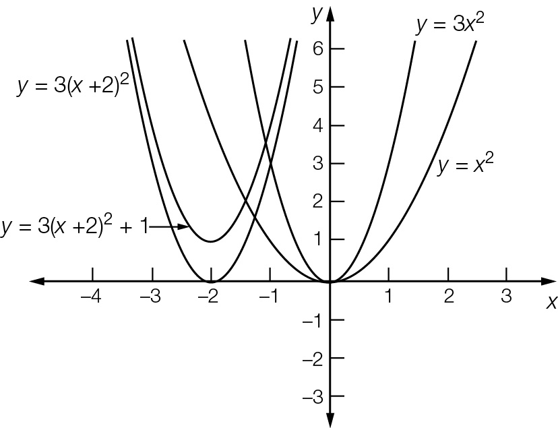

Question 18 3 marks [3.6]

45g2h2 – 5c2  
= 5(9g2h2 − c2)  
=5((3gh)2 − c2)  
=5(3gh − c)(3gh + c)

Question 19 3 marks [3.7]



Question 20 3 marks [3.7]



Short answer total marks: 34

Extended answer section

Question 21 5 marks [3.1]

(a)   


(b) 

(c) 

Question 22 5 marks [3.5, 3.6]

(a)  so 

(b) 

(c)



Question 23 6 marks [3.5]

(a) At t = 0, h = -02 + 9 × 0 + 10 = 10 m

(b) 

(c) The ball will hit the ground where h = 0. This occurs when t = 10.  
The value t = -1 is not possible because time must be positive.

Question 24 5 marks [3.1, 3.2]

|  |  |  |
| --- | --- | --- |
| (a) Vertical side length: a – x  Horizontal side length: b – x  PM2e_10_EB_02_SAT_02 | (b) First rectangle area: ax Second rectangle area: x(b – x) Total area:  ax + x(b – x) = ax + bx – x2 | (c)  Area of large rectangle: ab  Area of C: (a – x)(b – x)  Area of carpet:  ab – (a – x)(b – x)  = ab – ab + ax + bx – x2  = ax + bx – x2 |

Extended answer total marks: 21

TOTAL test marks: 63